Welcome JobRad to [Your Company]: Get up on your bike and save now!
Dear Employee,
Want to know the good news? You can now purchase your very own dream JobRad bike – electric or not – through [Your Company]. And getting started is so simple!
How does JobRad work?
[Your company] leases a JobRad bike for you. You can ride it whenever you want – to work, in your spare time, on holiday or for sport. Monthly instalments are automatically deducted from your gross salary over a period of 36 months. If you’d like further information, head over to the meinJobRad-Portal. You’ll find our top tips and more waiting for you there! You can even work out how much money you will personally save and learn about the service options available to you.
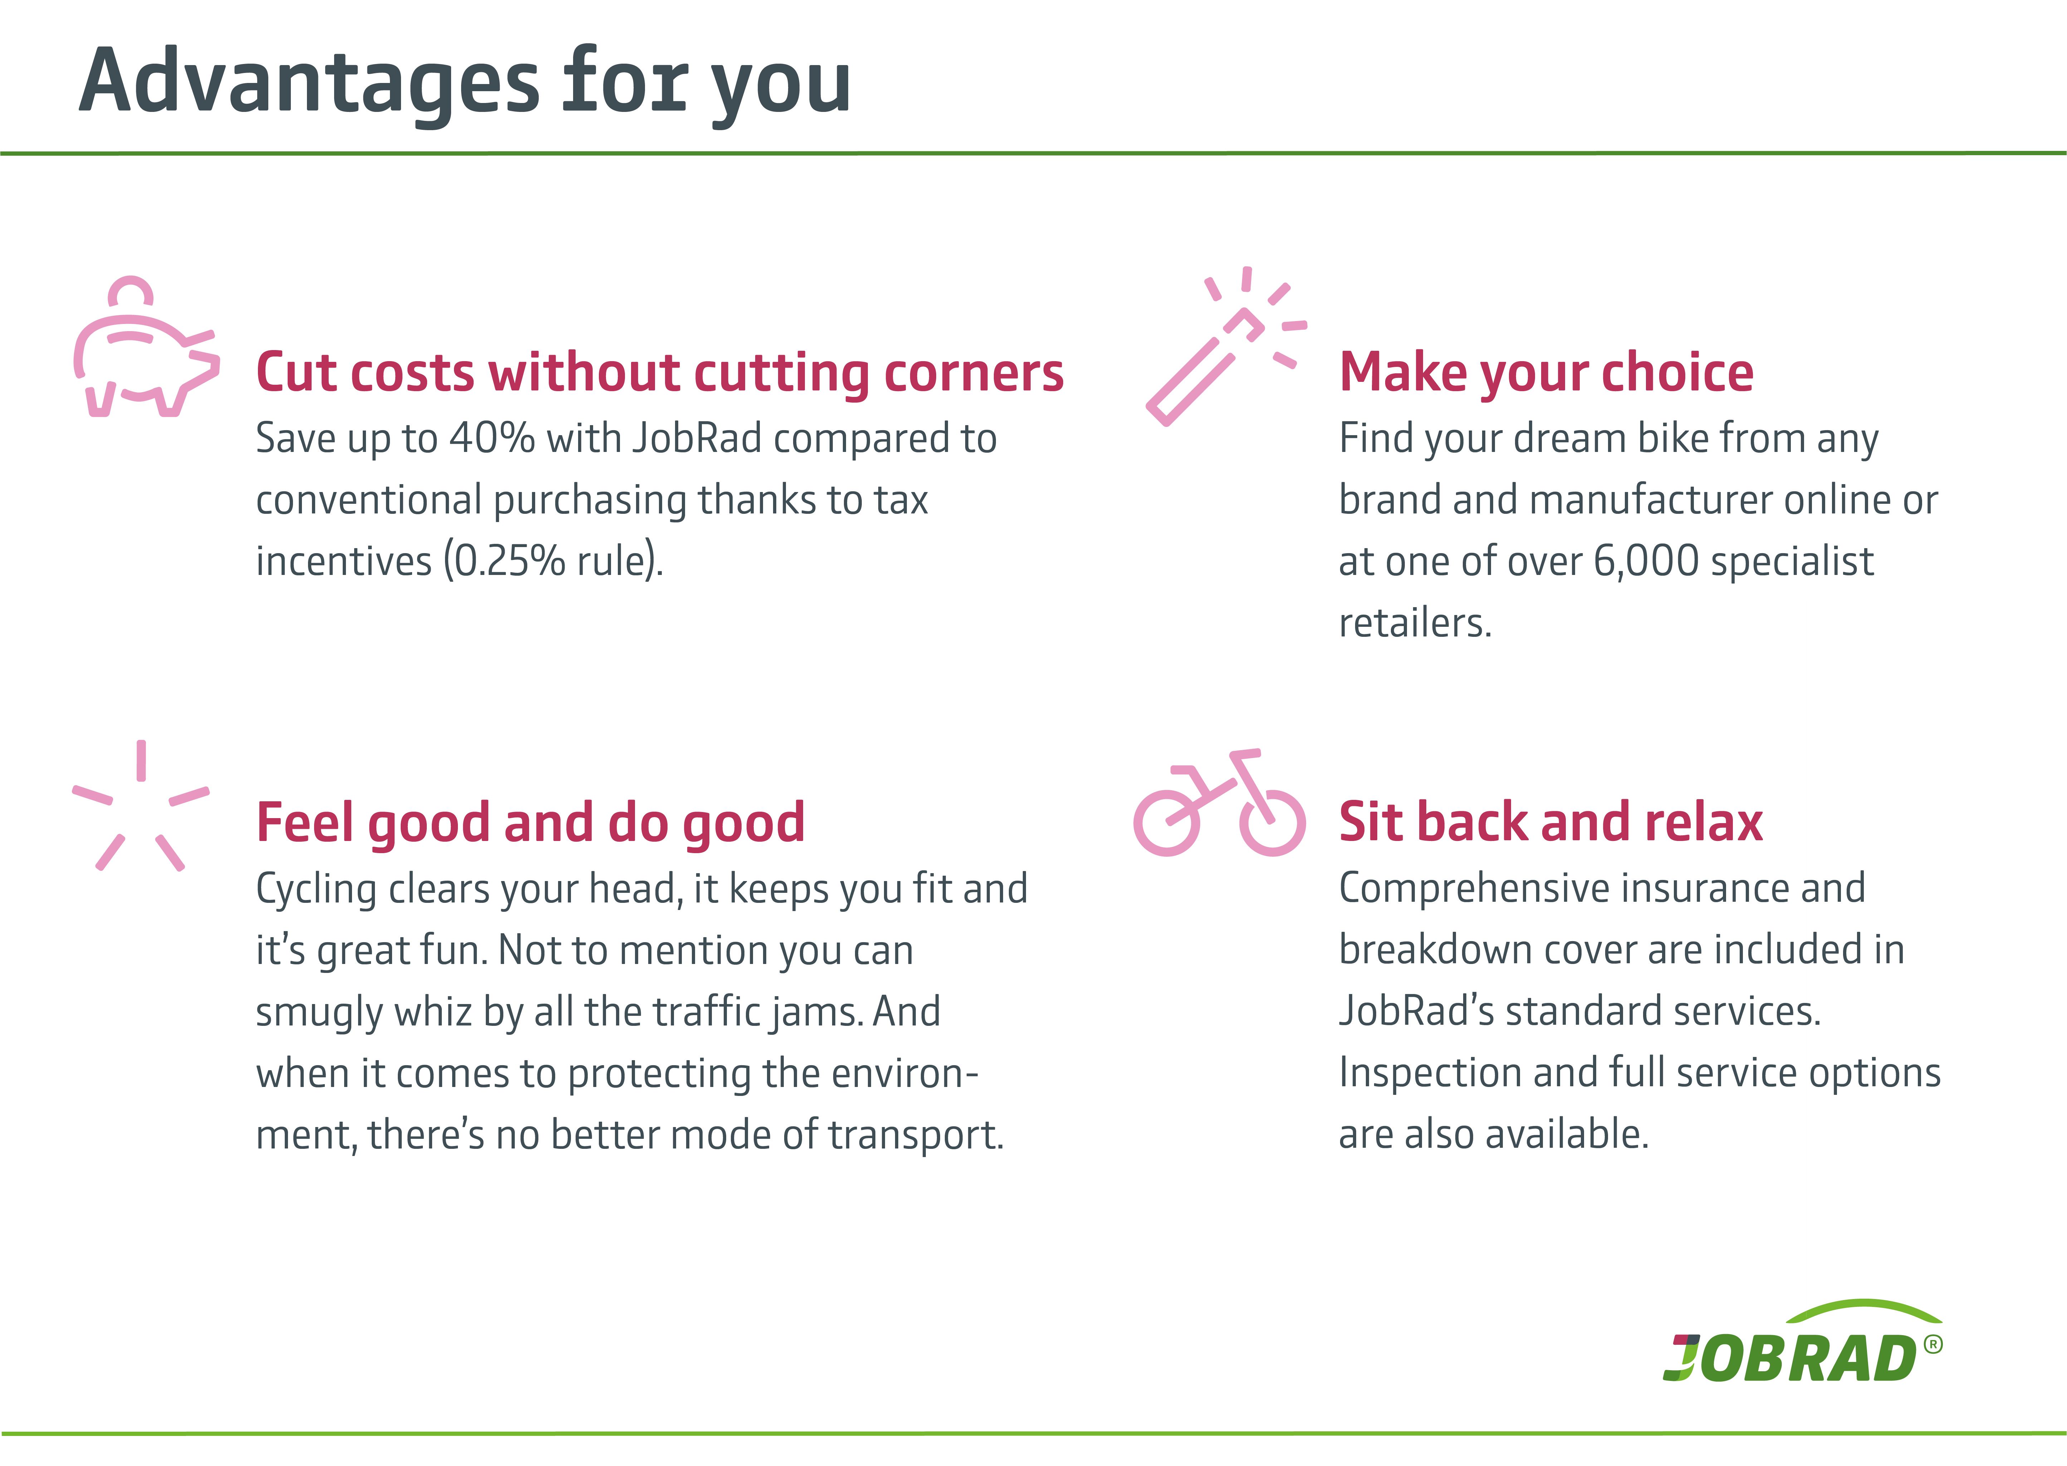
Say hello to your new [Your Company] JobRad in three simple steps
- Create an account on the meinJobRad-Portal.
- Get advice from one of over 6,000 JobRad retail partners in store or online.
- Once you’ve picked your dream bike, apply for it on the meinJobRad-Portal and secure those tax incentives.

We can’t wait to welcome you and lots of your colleagues at [Your Company] on board! Happy cycling!

